**RELATIONAL DATABASE DESIGN**

**LAB -2 ASSIGNMENT (GROUP PROJECT)**

**By: -Vidhya Venugopal (PROG8400-100-23S-2 1)**

**URL LINK FOR EER DIAGRAM: -**

<https://lucid.app/lucidchart/b3223f0f-3de1-403e-857b-60fdca1f5e7b/edit?viewport_loc=-959%2C156%2C4846%2C2078%2CHWEp-vi-RSFO&invitationId=inv_83c95844-e2a2-44e4-b7d8-d24873f31159>

1. **Add entity attributes (identifiers, atomic, derived, multivalued and composite)**

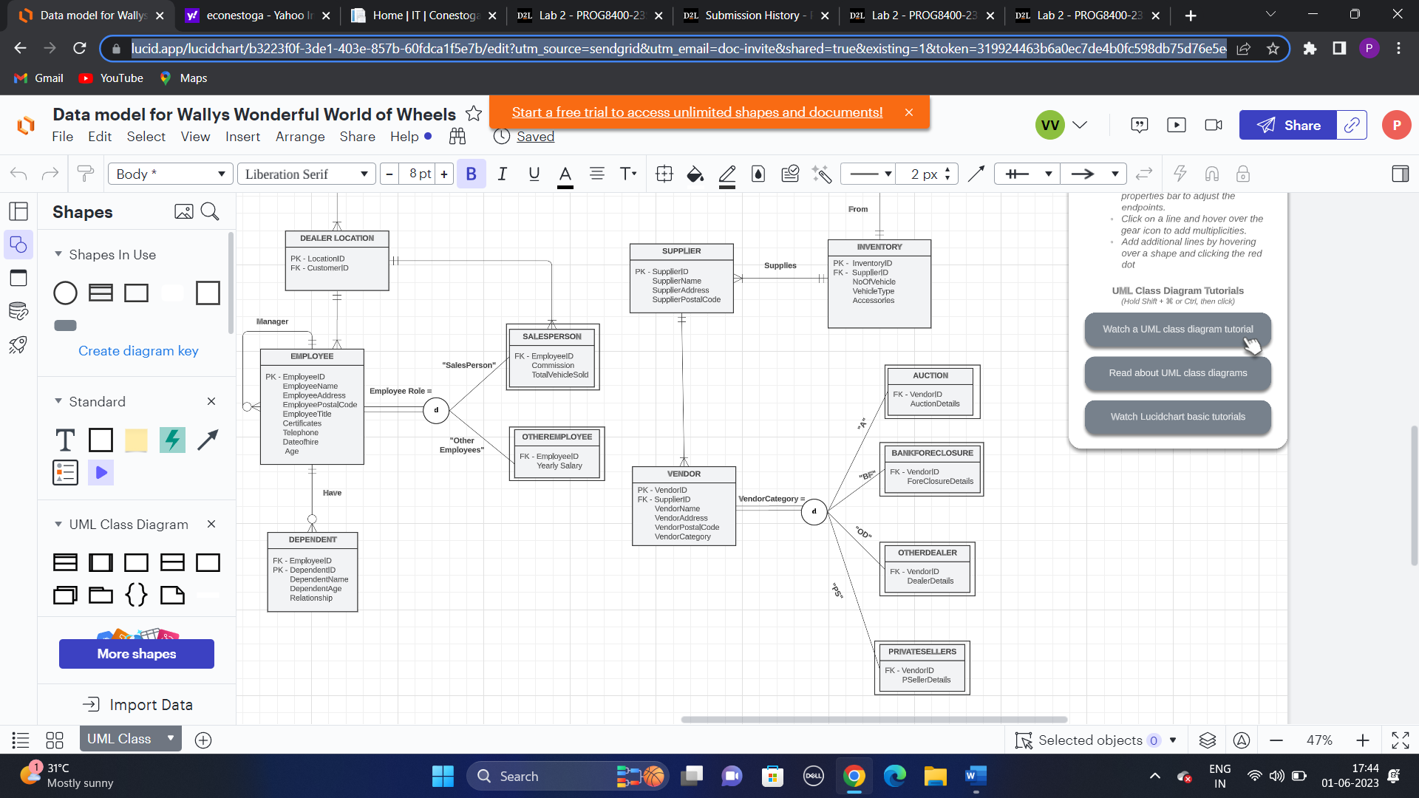

1. **Perform generalization and specialization**
2. **Add completeness constraints, specialization, disjoint and overlapping rules**

Employee can be either SalesPerson or Manager or otherEmployee. Therefore, Partial Specialization with disjoint rule is applied.

Vendor can be either in one of the following categories such as auction, bank foreclosure, other dealers, and private sellers. Therefore, Total Specialization with disjoint rule is applied.

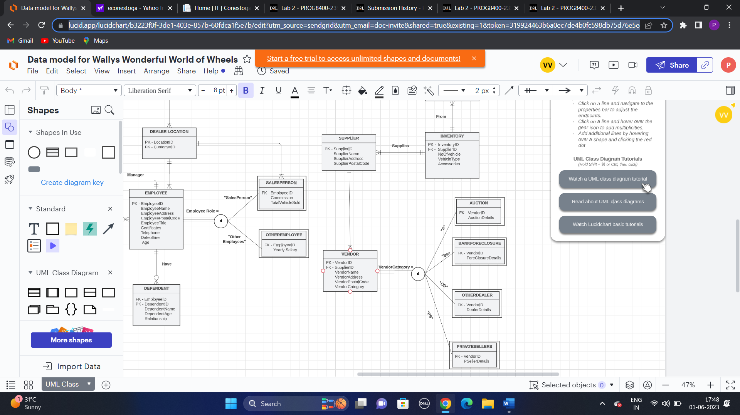

1. **Add subtype discriminators.**

Employee is a Supertype entity which has a subtype of manager which is unary relationship, SalesPerson and OtherEmployees. But the employee cannot be in all the entity in Salesperson or OtherEmloyees. He can be in either one of the subtypes, thus by achieving the subtype discriminators.